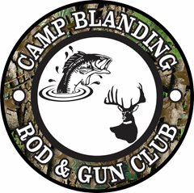

CAMP BLANDING ROD AND GUN CLUB HUNTER’S PLEDGE
Responsible hunting provides unique challenges and rewards. However, the
future of the sport and our club depends on each hunter's behavior and ethics.
Therefore, as hunters in the CAMP BLANDING ROD AND GUN CLUB, we pledge
to •••
-Adhere to the rules and regulations of FLORIDA FISH AND WILDLIFE
CONSERVATION COMMISSION.
-Adhere to the Rules, By-Laws, and MOA of the CAMP BLANDING ROD AND
GUN CLUB.
-Show respect for other hunters and non-hunters.
-Make safety first and foremost in all activities.
-Make a valid attempt at supporting CBJTC in all current and future volunteer
functions.
-Hunt only with ethical hunters who uphold FWC regulations.
By following these principles of conduct while hunting on CBJTC land, we will
give our best to the CBJTC, The Florida National Guard, and to the environment.
The responsibility to hunt ethically is ours; the future of hunting at CBJTC
depends on us.

